**Project Name:-**Developing a Backend Admin for Learner’s AcademyDeveloper

**Developer Name:-** Kunal B. Raskar

**Language:**Java.

**Objective of project:**

As a developer, write a program Developing a Backend Admin for Learner’s Academy.

**Functions and its description**:

This project aims to design and develop a backend administrative portal for the Learner’s Academy using Java EE technologies. I developed it as a project of phase 2 for the Become a back-end expert course. The goal of this project is to apply servlet, jsp and JDBC concepts.

**Technologies and tools Used**

• Servlet: to do the business logic and works a controller for the project.

• JSP: to handle the presentation view.

• SQL: to create and manage the database.

• JDBC: to make operations on the database for the project.

• CSS: to format the contents.

• phpMyAdmin: to administrate and manage the database manually.

• Eclipse: to write and run the code.

• Tomcat: to run and deploy servlet application.

**Flowcharts of The Application :-**

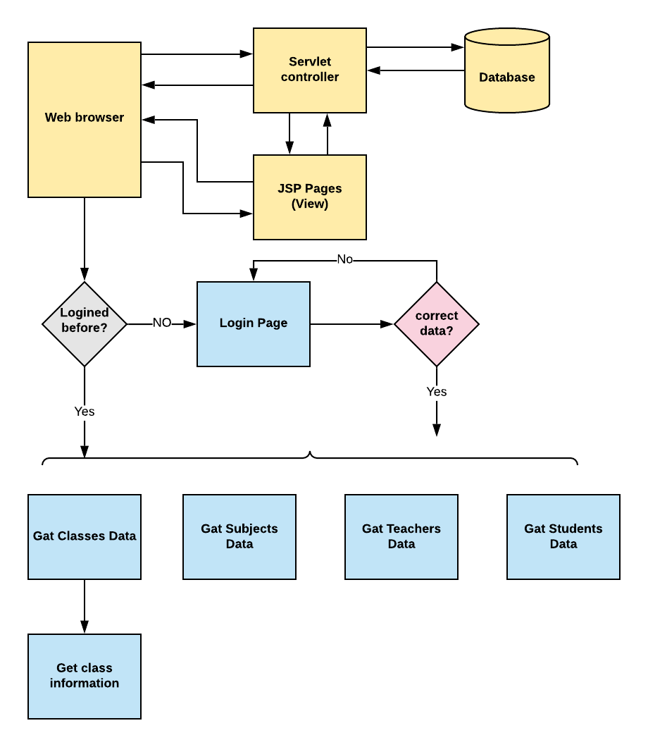

**Core concepts used in the project.**

• Object-Oriented: used to create and model objects for users and their credentials.

• Databases: used to store and retrieve data.

• Data Sources: used to define a set of properties required to identify and access the database.

• Collections: used some collections such arraylist to store collection of data.

• Exception Handling: used to catch problems that arises in the code especially in I/O blocks.

• Cookies: to store log-in data on the client browser.